**UNIVERSITY OF ENGINEERING AND TECHNOLOGY, LAHORE**

**(NAROWAL CAMPUS)**

**­**

**NAME :**

**ABDULAHAD HUSSAIN**

**ROLL NO. :**

**549**

**SECTION:**

**A**

**SUBJECT:**

**PROGRAMING FUNDAMENTAL**

**LAB #09:**

**Program No. 1:**

**Statement:**

Get division and number of subjects failed of student as input from keyboard and determine using the following chart that how many grace marks are to be awarded to him/her per subject failed.

|  |  |  |
| --- | --- | --- |
| **Division** | **No. Of subjects failed** | **Grace marks** |
| 1st | >3 | No grace marks |
|  | <=3 | 5 marks per subject |
| 2nd | >2 | No grace marks |
|  | <=2 | 4 marks per subject |
| 3rd | >1 | No grace marks |
|  | =1 | 5 grace marks |

**Source Code:**

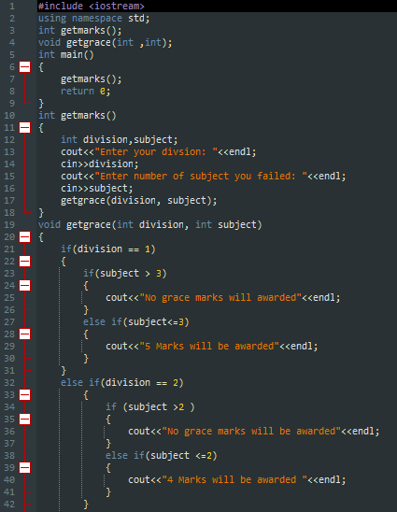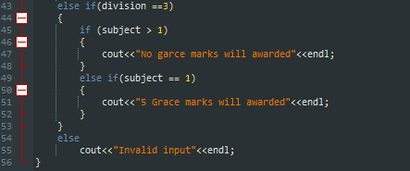

**Output:**

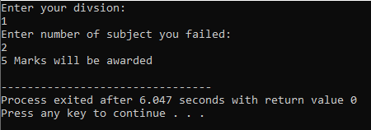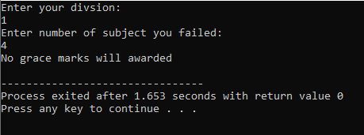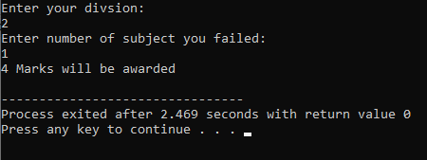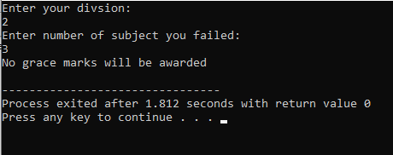

**Flow chart:**

**Program No. 2:**

**Statement:**

Get a positive integer from user as input and determine its factorial.

**Source Code:**

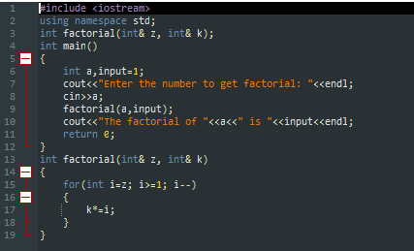

**Output:**

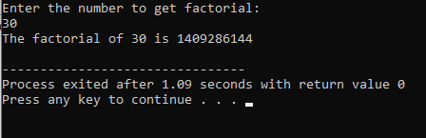

**Flow Chart:**